TASK: Starting a instance as per the particular time and stop. By using Lambda

Create EC2.
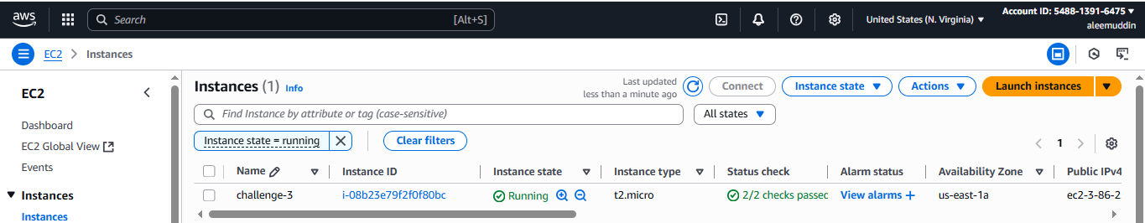

Create a lambda function
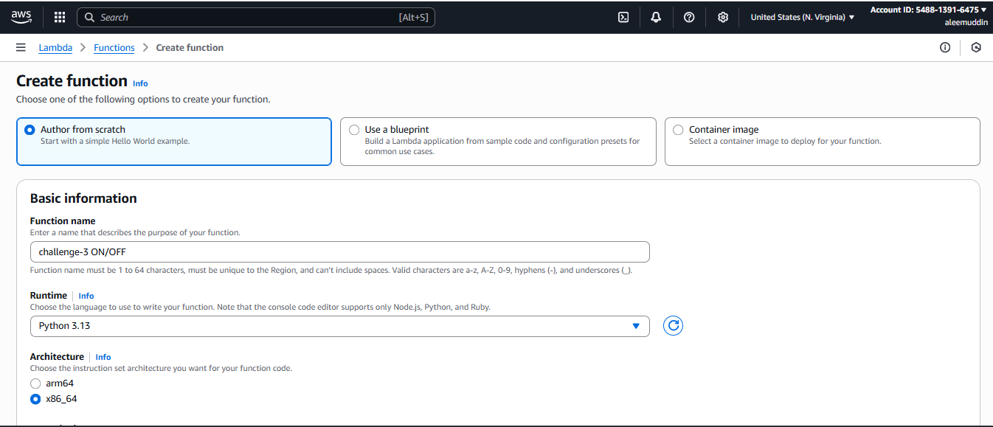

Create IAM Policy to start & stop the instance
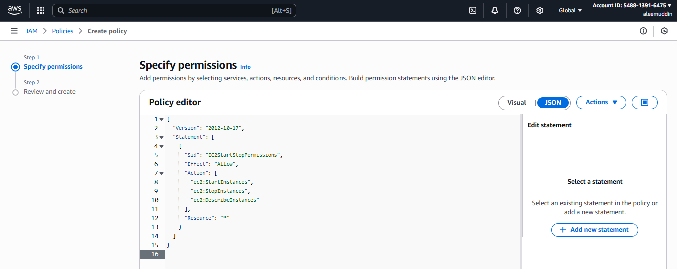
{
"Version": "2012-10-17",
"Statement": [
{
"Sid": "EC2StartStopPermissions",
"Effect": "Allow",
"Action": [
"ec2:StartInstances",
"ec2:StopInstances",
"ec2:DescribeInstances"
],
"Resource": "*"
}
]
}

Create IAM Role
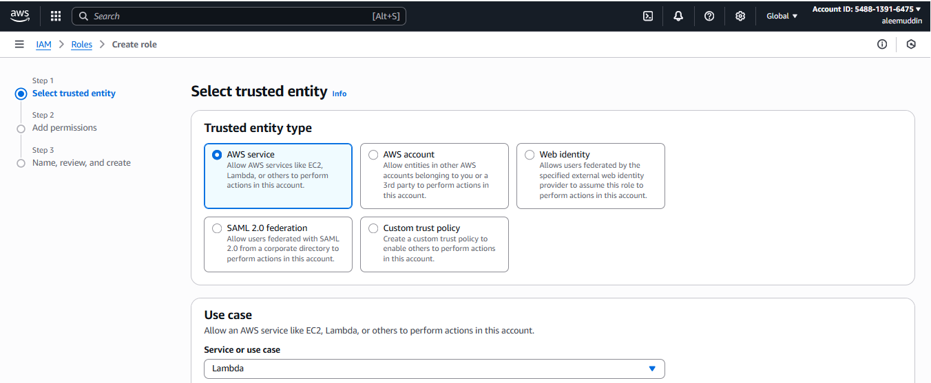
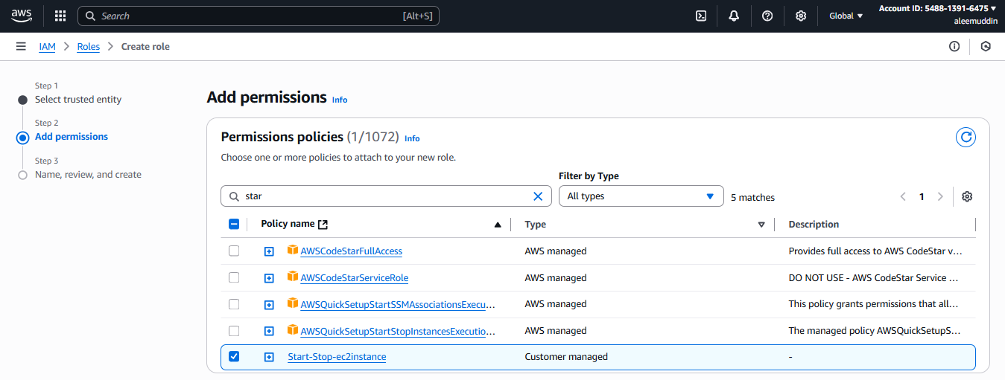

Back to lambda to select existing role and check function is created or not then select and create the lambda.

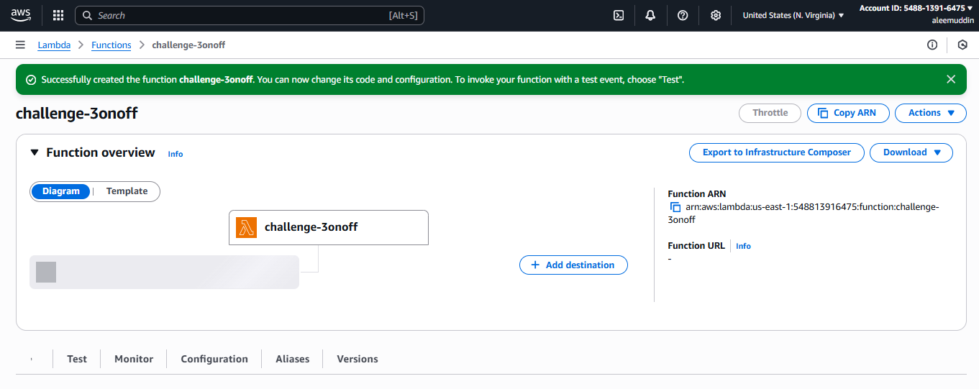

Python code for start instance

import boto3

# EC2 client
ec2 = boto3.client('ec2')

# Your specific instance ID
INSTANCE_ID = "i-08b23e79f2f0f80bc"

def lambda_handler(event, context):
try:
ec2.start_instances(InstanceIds=[INSTANCE_ID])
return {
"statusCode": 200,
"body": f"✅ Successfully started instance {INSTANCE_ID}"
}
except Exception as e:
return {
"statusCode": 500,
"body": f"❌ Error: {str(e)}"
}
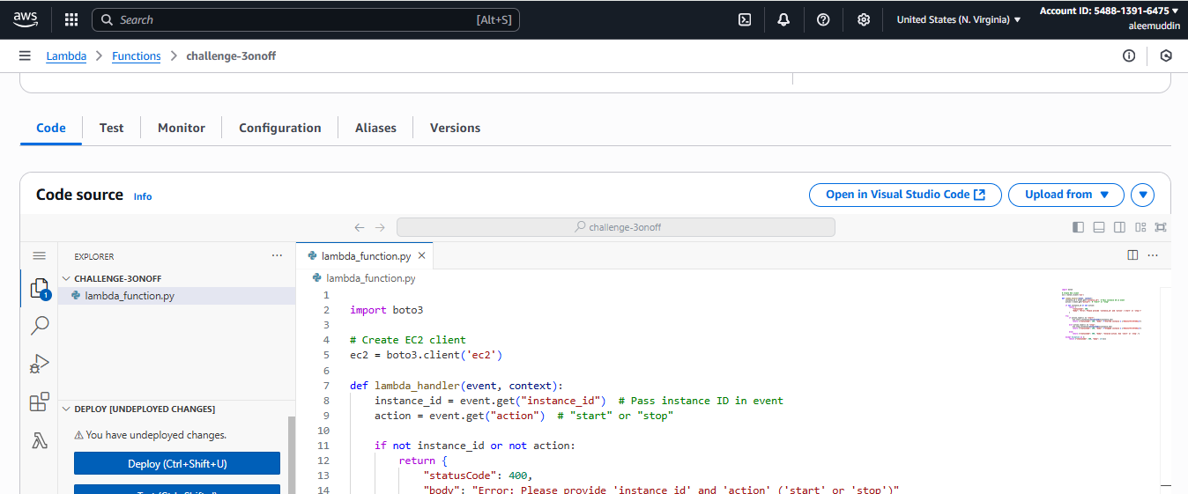
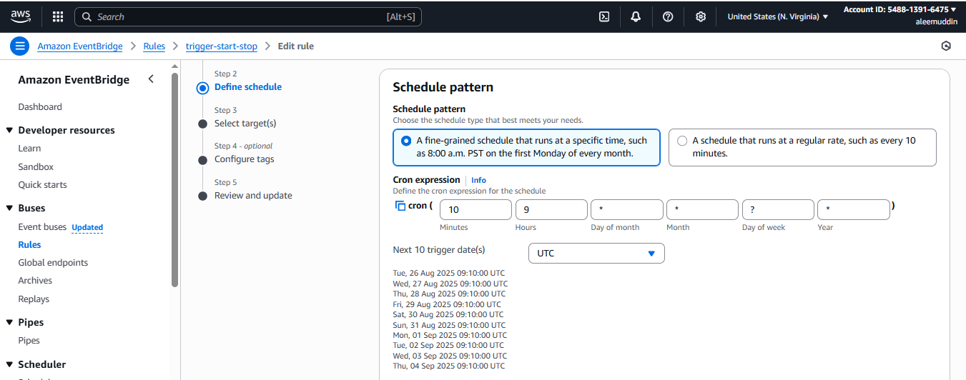
Start status as per the cron settings
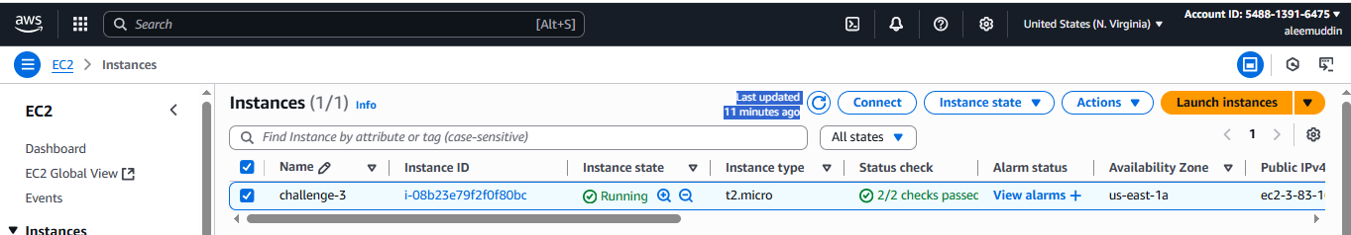

Again add one more Lambda to stop instance
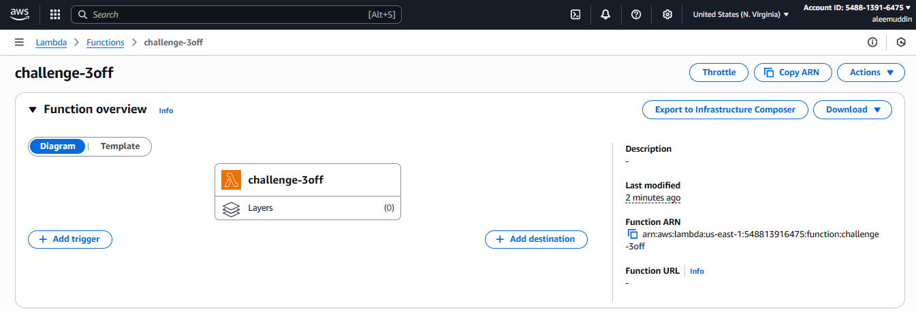

Python code to stop instance

import boto3

# EC2 client
ec2 = boto3.client('ec2')

# Your specific instance ID
INSTANCE_ID = "i-08b23e79f2f0f80bc"

def lambda_handler(event, context):
try:
ec2.stop_instances(InstanceIds=[INSTANCE_ID])
return {
"statusCode": 200,
"body": f"✅ Successfully stopped instance {INSTANCE_ID}"
}
except Exception as e:
return {
"statusCode": 500,
"body": f"❌ Error: {str(e)}"
}
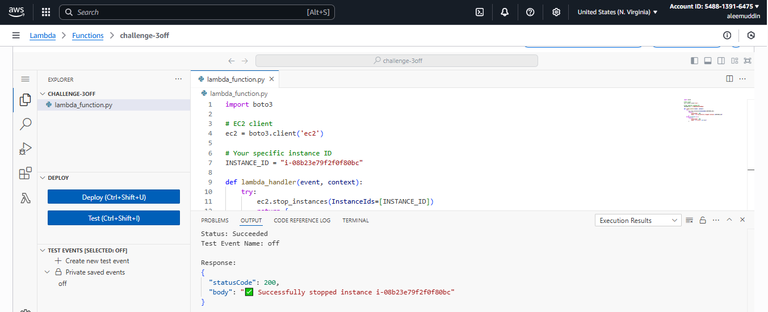
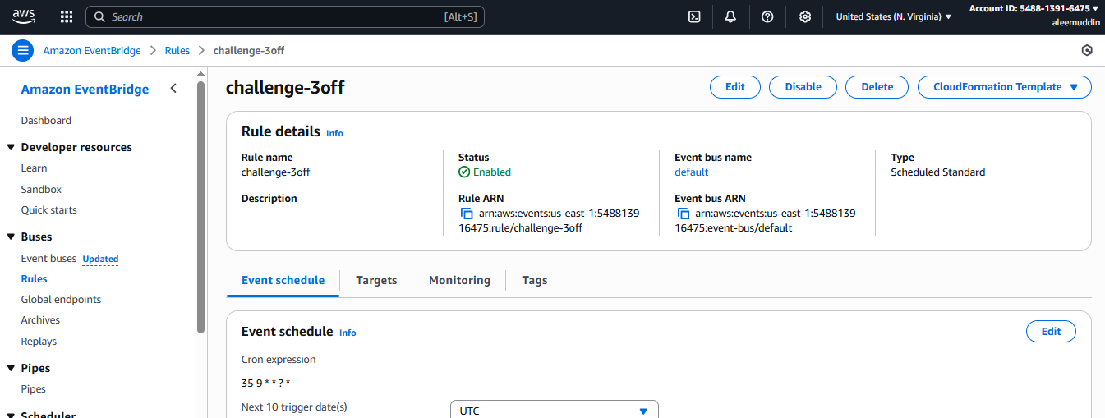

Stop status as per the cron settings

